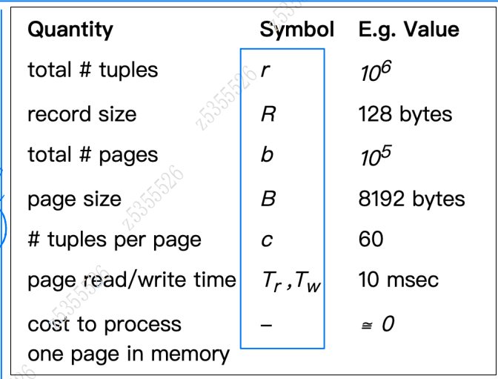

Consider a Students relation defined as:

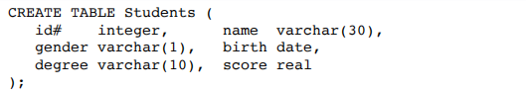

Assume that:

There are 20,000 student records

The relation is stored in one file

The file is composed of 1024-byte blocks

Average block-fetch time (*Tr*) is 10ms

A date is represented by an 8-byte long value

All numeric values must be stored on 4-byte address boundaries

Average length of name value is 15 chars

Average length of degree value is 5 chars

Consider two possible storage structures:

i. fixed-length records with a presence bit-vector

ii. variable-length records with a fixed-size directory containing one-byte offset values

For each of these structures:

a. Show the internal record structure and compute the (average) size of a record

b. Compute how many blocks are needed to store the whole relation

c. Compute how long it takes to answer a query on id# if the file is sorted on this field (worst case value)

**Answer:**

i. fixed-length records with a presence bit-vector ...

a. Show the internal record structure and compute the (average) size of a record ...

Each record has something like the following structure, where fields are arranged to ensure that no numeric field begins on a non-aligned address

boundary

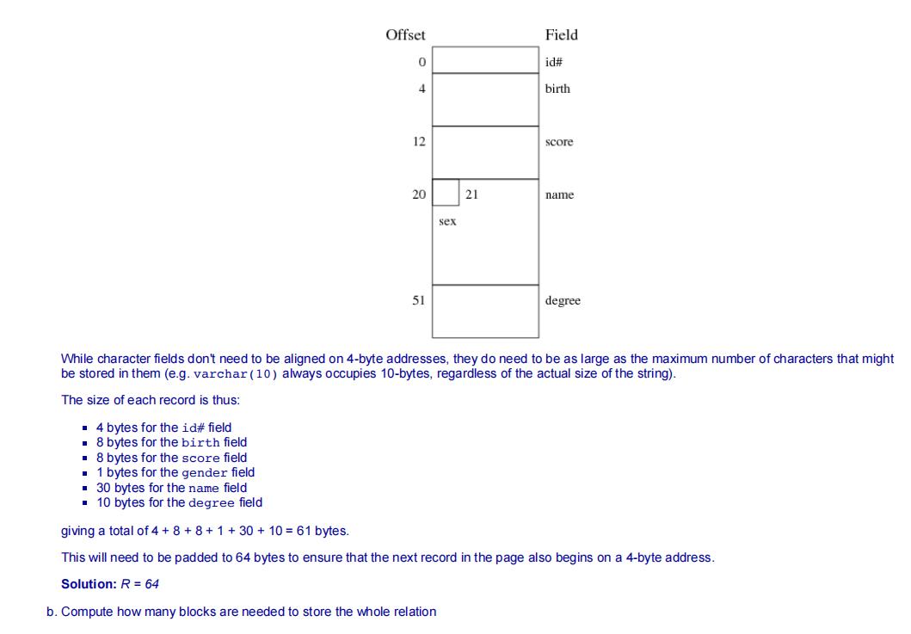

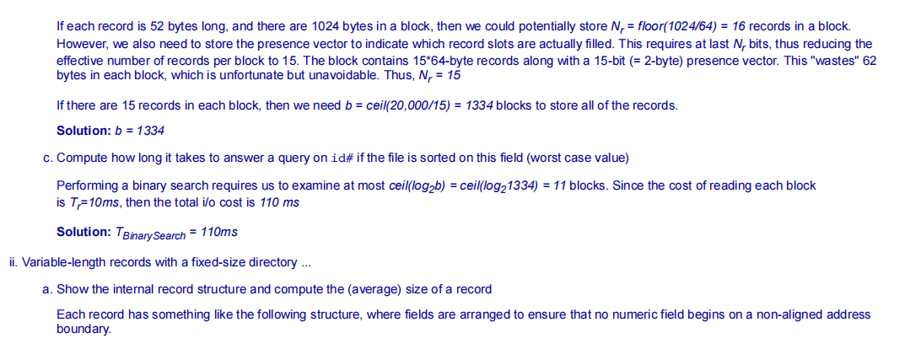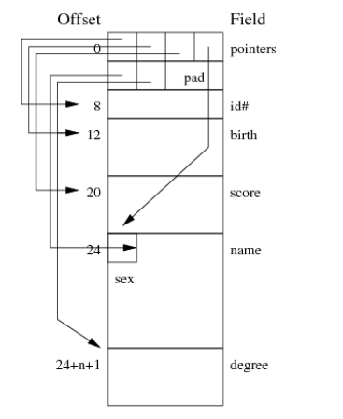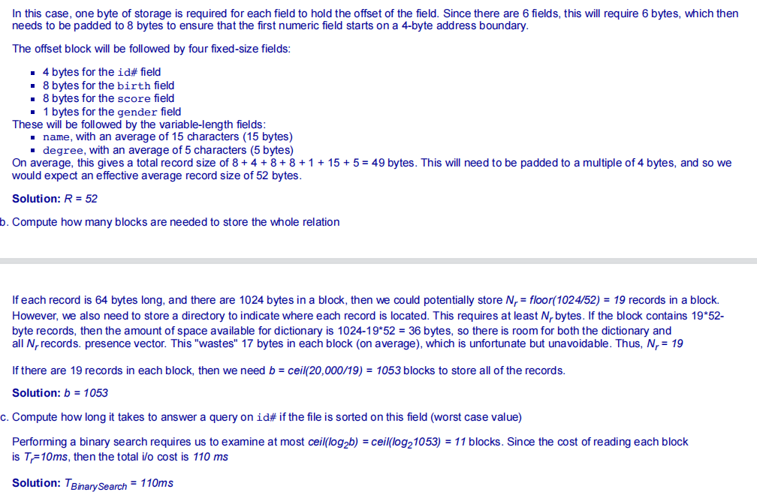

Clock-swap strategy(R, with bR=4, and S, with bS=3)

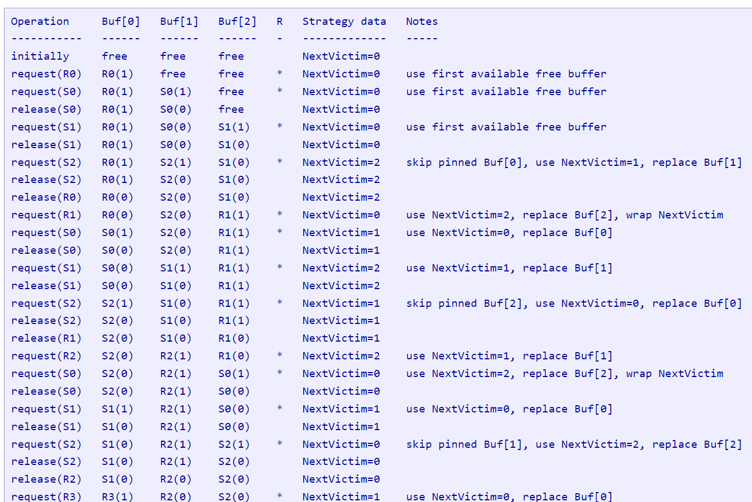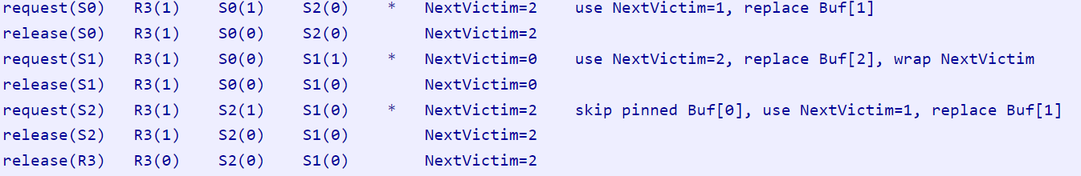

LRU最近最少使用

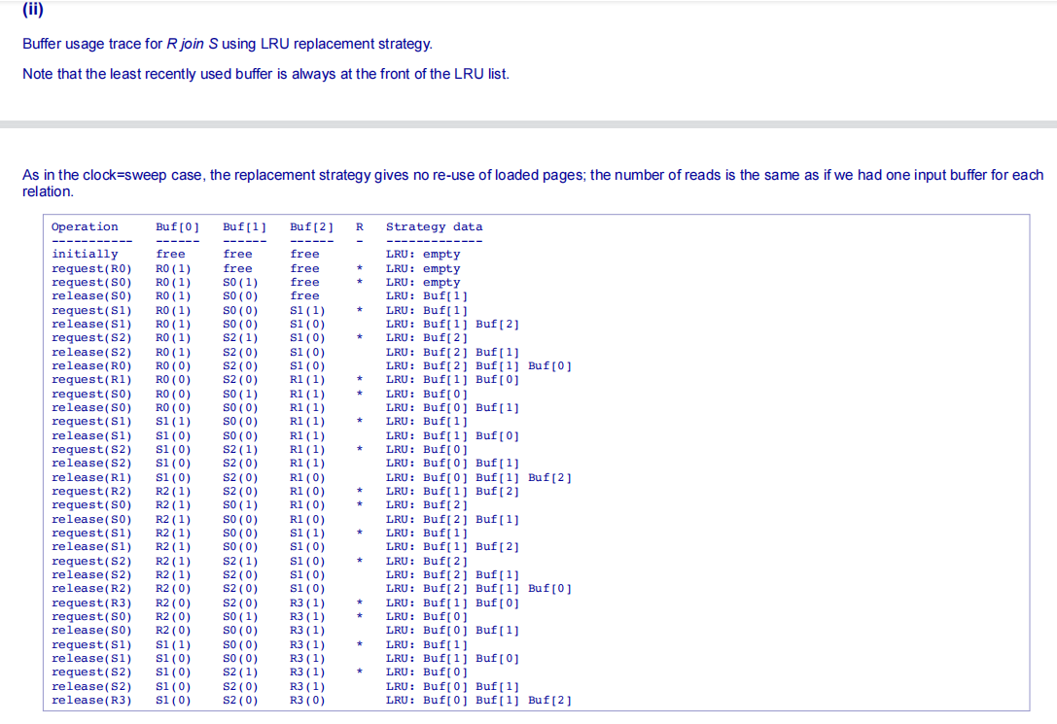

MRU最近最常使用

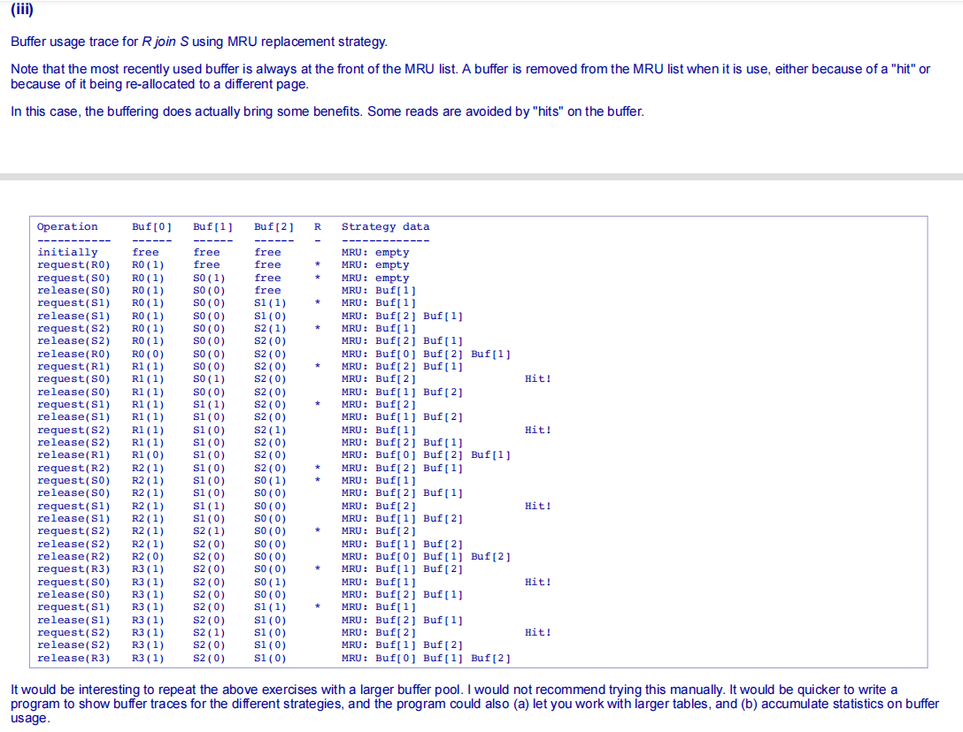

1. You have an unsorted heap file containing 4500 records and a select query is asked that requires the file to be sorted. The DBMS uses an external

merge-sort that makes efficient use of the available buffer space.

Assume that: records are 48-bytes long (including a 4-byte sort key); the page size is 512-bytes; each page has 12 bytes of control information in it; 4

buffer pages are available.

a. How many sorted subfiles will there be after the initial pass of the sort algorithm? How long will each subfile be? （ceil(b/buffers)）

**Answer:**

We need to first of all work out the blocking factor and then the number of data blocks. The available space for storing records in each page is

512-12=500 bytes, so each page can store up to 10 48-byte records. This means that 450 pages are needed to store the 4500 records.

In the first pass, we read as many pages as we can into the available buffers, sort these page in memory, and then write them out. Given that 4

buffer pages are available, there will be ceil(450/4)=113 sorted runs (sub-files) of 4 pages each, except the last run which is only 2 pages long.

b. How many passes (including the initial pass considered above) will be required to sort this file? 1+log_{N-1}(ceil(b/buffers))

**Answer:**

After pass 0, we have N=ceil(b/B) sorted runs, each of length B. Subsequent merging passes will increase the length of the sorted runs by B-1

times on each pass. The number of merging passes until the whole file is sorted is ceil(logB-1N).

For this scenario, b=450, B=4, N=113 so #passes = 1 + ceil(log4-1113) = 6.

c. What will be the total I/O cost for sorting this file? 2b(1+log_{N-1}(ceil(b/buffers)))

**Answer:**

Each pass requires us to read and write every page in the file. The total number of I/O operations is thus 2*b*#passes. The total cost for sorting

this file is 2 * 450 * 6 = 5,400 I/Os.

d. What is the largest file, in terms of the number of records, that you can sort with just 4 buffer pages in 2 passes? (用abc的公式反向推)How would your answer change if you had 257 buffer pages?

**Answer:**

We first need to work out the answer in terms of number of pages (b), and then convert to number of records.In pass 0, ceil(b/B) runs are produced. In pass 1, we must have enough buffers to enable us to merge this many runs, so B-1 must be larger or

equal to ceil(b/B). Given B, we can determine b by "solving" (B-1) ≥ ceil(b/B). Re-arranging the formula (with a few simplifying assumptions)

gives b = B*(B-1).

When B is given to be 4, b = 4*(4-1) = 12. The maximum number of records on 12 pages is 12*10=120.

When B is given as 257, b= 257*256 = 65792, with 65792*10=657920 records.

**Cost of sort-based Projection and hash-based projection**

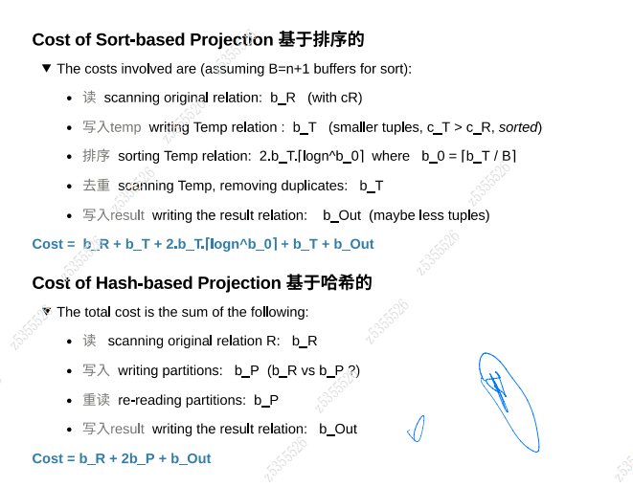

**Dense Index Sparse Index**

**(dense是每个Tuple做一个index（每个index所占空间为要存储的值的大小和存储key的address的大小）放到index file中)**

**(sparse是每个Page做一个index（每个index所占空间为要存储的值的大小和存储key的address的大小）放到index file中)**

Consider the relations:

Student(**id#**, name, age, course)

Subject(**code**, title, description)

Make the following assumptions:

rStudent = 50,000, rSubject = 5,000

the data file for Student is sorted on id#, the data file for Subject is sorted on code

simple one-level indexes are used (e.g. because the files are reasonably static)

record IDs (RIDs) are 4-bytes long

all data pages and index pages are 4KB long

Based on these assumptions, answer the following:

a. You can build a dense index on any field. Why?

Answer:

A dense index has one index entry for each data record. It is required that the entries in the index are sorted (to make searching the index

efficient). However, there are no specific requirements on where the records are located within the data file. Thus, you can build a dense index

on any or all fields.

**b. On which field(s) could you build a non-dense index?**

Answer:

A non-dense index has one entry per block, and assumes that all records in that block have key values less than all key values in the next

block. Thus, you can only build non-dense indexes on a field (key) on which the relation is sorted.

**c. If the student id# is a 4-byte quantity, how large would a dense index on Student.id# be?**

Answer:

A dense index has one entry per data record, so we have 50,000 entries. Each index entry contains a copy of the key value and the address of

the page where the record containing that key is stored. Index entries will thus have 4-bytes for the id# and 4-bytes for the page address, so

we can fit floor(4096/8) = 512 index entries per page. The number of index pages required is then ceil(50000/512) = 98.

**d. If the subject code is an 8-byte quantity, how large would a dense index on Subject.code be?**

Answer:

Same reasoning as for previous question. 5,000 index entries. Each index entry contains 8-bytes (for subject code) + 4 bytes for page address.

Each index page contains floor(4096/12) = 341 index entries. And so the number of index pages is ceil(5000/341) = 15.

**e. If the cStudent = 100 and cSubject = 20, and other values are as above, how large would non-dense indexes on Student.id# and**

**Subject.code be?**

Answer:

For a non-dense index, we need only one index entry per block of the data file. Assuming that the files are fully compacted, the Student file

has ceil(50000/100) = 500 blocks, and the Subject file has ceil(5000/20) = 250 blocks. The analysis then proceeds as for the previous

question, except with one index entry per block.

Thus #index blocks for Student = ceil(500/512) = 1, and #index blocks for Subject = ceil(250/341) = 1

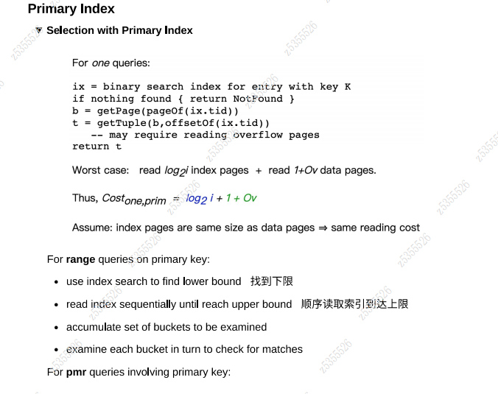

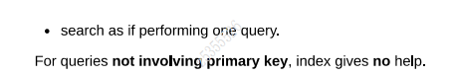

**f. If you had just dense indexes on Student.id# and Subject.code, briefly describe efficient processing strategies for the following queries:**

i. select name from Student where id=2233445

ii. select title from Subject where code >= 'COMP1000' and code < 'COMP2000'

iii. select id#,name from Student where age=18

iv. select code,title from Subject where title like '%Comput%'

Answer:

i. select name from Student where id=2233445

Do a binary search through the index (max log298=7 page reads) to find the entry for 2233445 and then fetch the data block containing

that record (if it exists).

ii. select title from Subject where code >= 'COMP1000' and code < 'COMP2000'

Do a binary search through the index (max log215=4 page reads) to find the page for COMP1000 (or nearest similar subject), and then

do a scan through the data file to grab all the COMP1xxx records, which will appear consecutively.

iii. select id#,name from Student where age=18

Since the index provides no assistance, the simplest solution is probably just to scan the entire file and select the 18-year-olds as you

go. Sorting the file doesn't help here.

iv. select code,title from Subject where title like '%Comput%'Once again, the index doesn't help, so a linear scan is the only option.

**g. What techniques could you use to improve the performance of each of the above queries? And how would it impact the other queries?**

Answer:

i. You could do better than the above by using either hashing (which would require only one page access) or a balanced tree index (e.g. B

tree), which would require at most three. Hashing would not be an option if there was some reason why the file had to be maintained in

order on the student id.

ii. A balanced tree index like a B-tree on the code field would also help here.

iii. If this was a common kind of query (lookup by specific age), and if there was no requirement to keep the file in any particular order, you

could hash the file on age to improve performance. A more likely scenario would be to add a dense index on the age field.

iv. You can't use an index to assist with this query, because it doesn't use a notion of "matching" that involves the natural ordering on the

field values. The query could match "Intro to Computing" or "Computing 1A" or "Mathematical Computation" etc.

**Linear Hashing**

Consider a linear hashed file with the following properties

* initially with 2 (empty) pages in the file, *d* = 1, *sp* = 0
* able to hold up to 2 tuples per page
* an associated overflow file (initially empty, no pages)
* each page in the overflow file can also hold up to 2 tuples

A set of numeric keys (the numbers 1 to 32) are inserted into the file, in numeric order. Splits occur just before the insertion of the keys 6, 12, 18, 24, 30 The hash value of each key is simply the binary value of the number (e.g. hash(1) = 00000001, hash(15) = 00001111, and hash(21) = 00010101).

Show the state of the file(s) at the following points:

immediately before each split operation (before inserting the new value)

immediately after each split operation and after inserting the new value

The state should include:

* the pages of the data file, with tuples indicated by key values
* the depth of the file (*d*), the position of the split pointer (*sp*)
* any overflow pages, linked to their corresponding data pages by arrows(SP的变化为为易错点）

State before inserting 6

d=1, sp=0

[0] 2,4

[1] 1,3->5

State after splitting and inserting 6

d=1, sp=1

[0] 4

[1] 1,3->5

[2] 2,6

State before inserting 12

d=1, sp=1

[0] 4,8

[1] 1,3->5,7->9,11

[2] 2,6->10

State after splitting and inserting 12

d=2, sp=0

[0] 4,8->12

[1] 1,5->9

[2] 2,6->10

[3] 3,7->11

State before inserting 18

d=2, sp=0

[0] 4,8->12,16

[1] 1,5->9,13->17

[2] 2,6->10,14

[3] 3,7->11,15

State after splitting and inserting 18

d=2, sp=1

[0] 8,16

[1] 1,5->9,13->17

[2] 2,6->10,14->18

[3] 3,7->11,15

[4] 4,12

State before inserting 24

d=2, sp=1

[0] 8,16

[1] 1,5->9,13->17,21

[2] 2,6->10,14->18,22

[3] 3,7->11,15->19,23

[4] 4,12-->20

State after splitting and inserting 24

d=2, sp=2

[0] 8,16->24

[1] 1,9->17

[2] 2,6->10,14->18,22

[3] 3,7->11,15->19,23

[4] 4,12-->20

[5] 5,13->21

State before inserting 30

d=2, sp=2

[0] 8,16->24

[1] 1,9->17,25

[2] 2,6->10,14->18,22->26

[3] 3,7->11,15->19,23->27

[4] 4,12-->20,28

[5] 5,13->21,29

State after splitting and inserting 30

d=2, sp=3

[0] 8,16->24

[1] 1,9->17,25

[2] 2,10->18,26

[3] 3,7->11,15->19,23->27

[4] 4,12-->20,28

[5] 5,13->21,29

[6] 6,14->22,30

Multiple Attributes（MA Hashing）

Consider a file of *n=50000* tuples allocated across *b=1024* pages using a multi-attribute hash function giving *d=10* hash bits. The tuples in this file have four fields *R(w,x,y,z)* and a choice vector that allocates hash bits to fields as follows: *dw=5, dx=2, dy=3, dz=0*. Assuming that there are no overflow pages, compute how many pages each of the following queries would need to access:

**select * from R where w=5432 and x=3**

The specified attributes (*w,x*) contribute 5+2 known bits, leaving 3 bits unknown. We need to generate all possible values for these 3 bits, which means we need to examine **8 pages** for possible matches.

**select * from R where w=9876 and x>5**

The query term x>5 is not useful for hashing

Thus, the only attribute with a specified value useful for hashing is *w*, which contributes 5 known bits. This leaves 5 unknown bits and so we need to examine *25* = **32 pages** which may contain matching tuples.

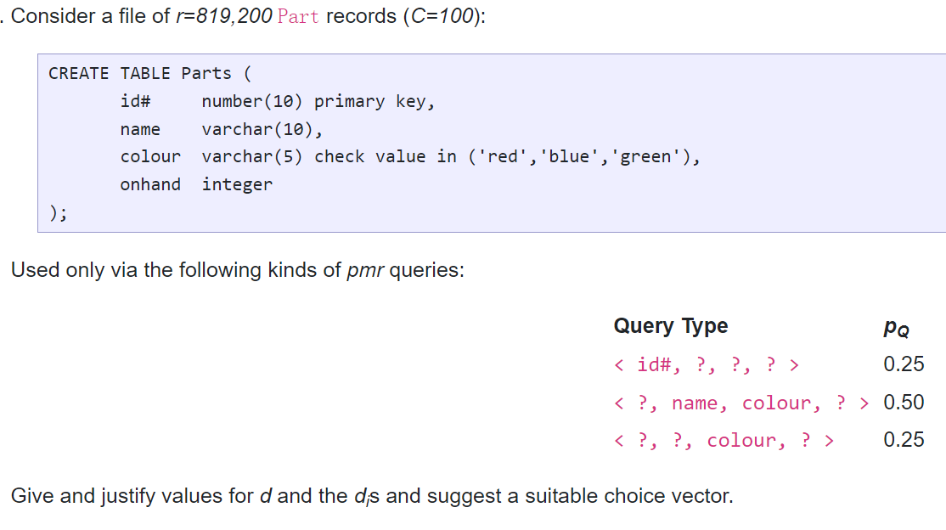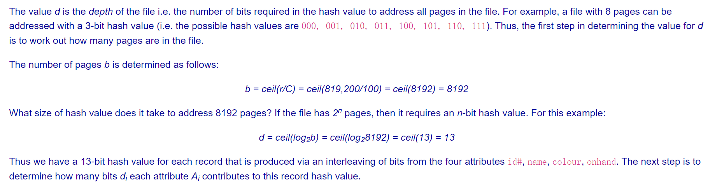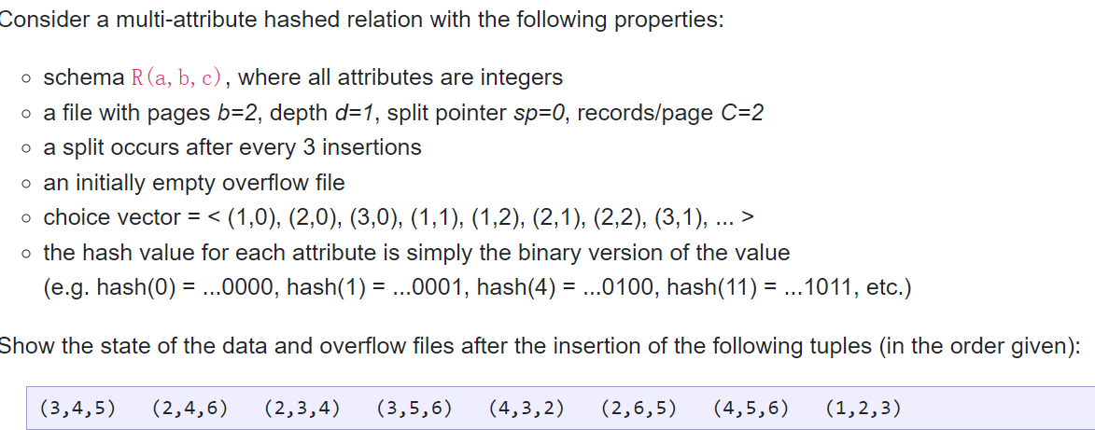

先将Tuple中的每个数字的哈希值写出来，然后用choice vector写出Tuple的ma hashing值

Cv=<(1,0)，（2,0）...>对于（3,4）hash(3)=0011,hash(4)=0100，Ma-hashing为...01

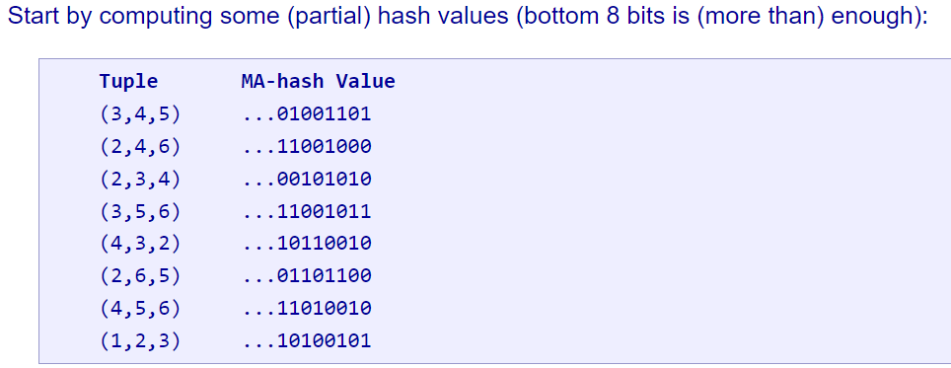

**Signature-based selection**

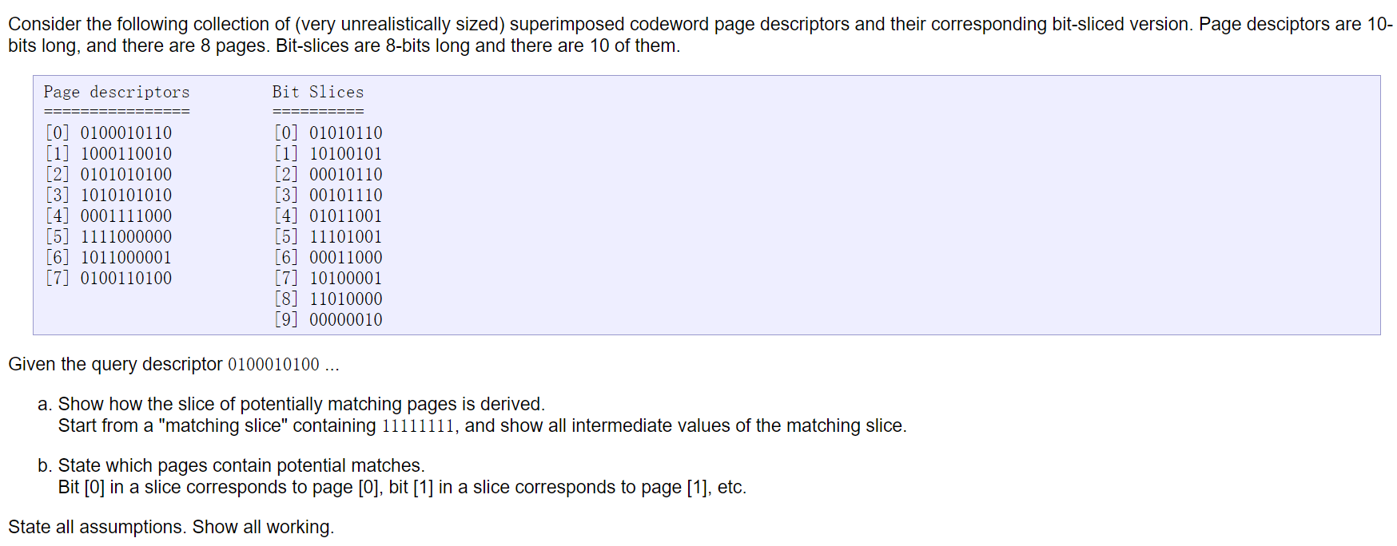

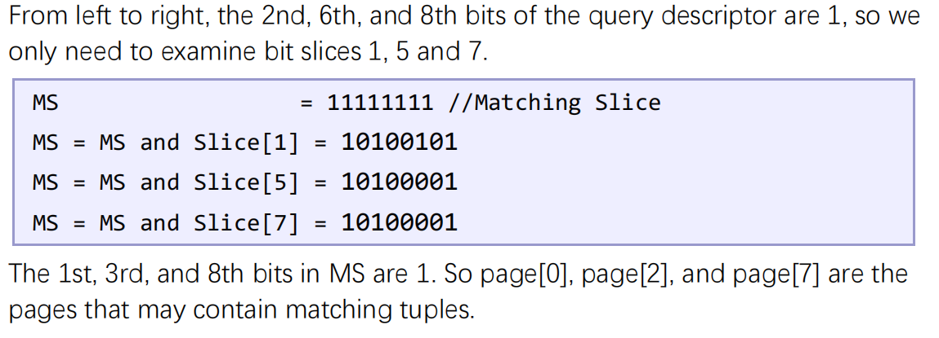

先找到query descriptor中为1的索引对应在Bit Slices中的bit descriptors,将其依次与matching slice进行按位与运算，得到的结果中为1的索引对应的page即为可能包含matching tuples的page（page descriptors的每一列表示Tuple，行即为page；bit slices的每一列代表page，行为Tuple）

n = 6 attributes

r = 40,000 records

B = 1024 bytes/block

C = 20 recs/block

pF = 10-4

For record signatures, we use the formulae:

k = loge(1/pF) / (loge2)

m = n * loge(1/pF) / ((loge2) 2)

For block (page) signatures, we use the formulae:

k = loge(1/pF) / (loge2)

m = n * C * loge(1/pF) / ((loge2) 2)

 Nested-loop, Sort-merge, Hash

Consider the join *Join[R.a=S.b](R,S)* and the following information about the relations to be joined:

* Relation *R* contains 10,000 tuples and has 10 tuples per page
* Relation *S* contains 2,000 tuples and also has 10 tuples per page
* Attribute *b* of relation *S* is the primary key for *S*
* Both of the relations are stored as simple heap files
* Neither relation has any indexes built on it
* There are 52 buffer pages available

Unless otherwise noted, compute all costs as number of page I/Os, except that the cost of writing out the result should be uniformly ignored (it's the same for all methods).

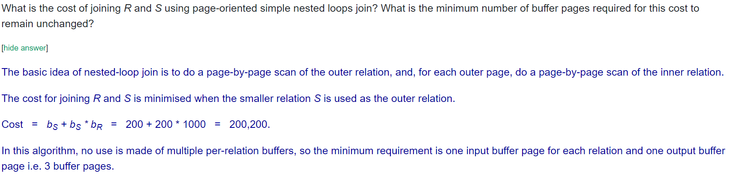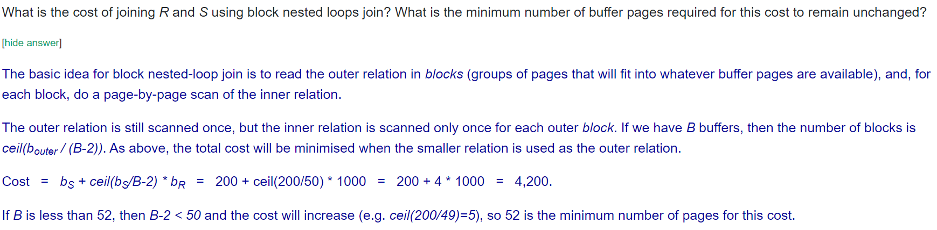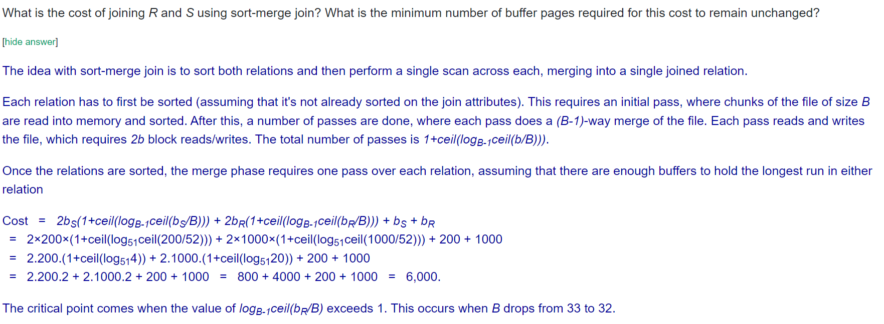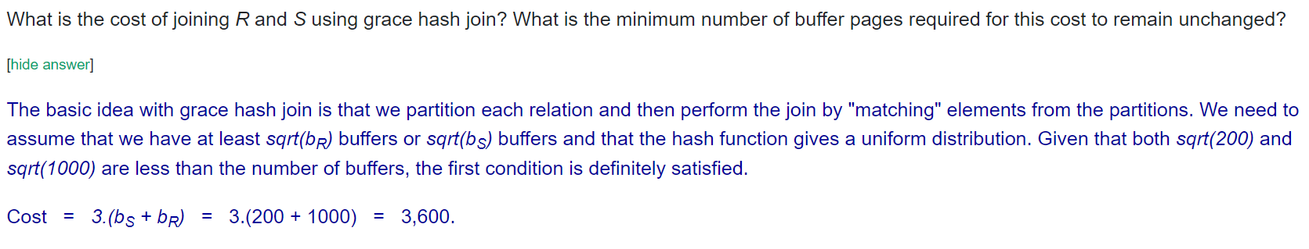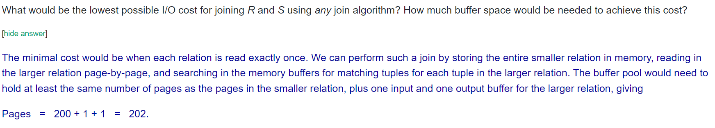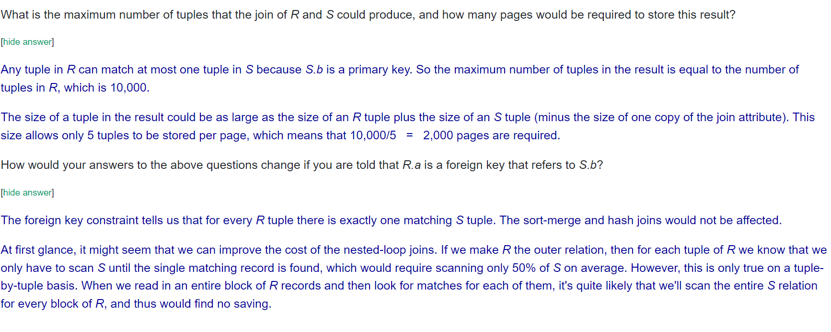

Hybrid hash cost:

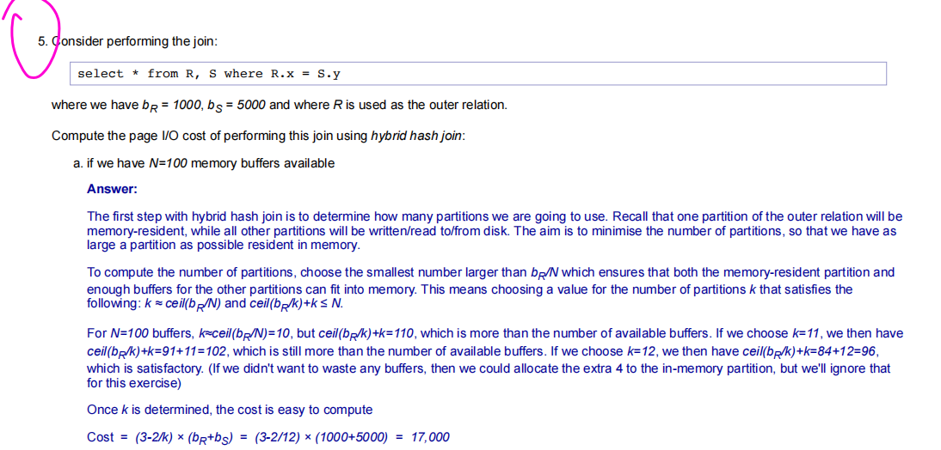

K = ceil(br/N) ceil(br/K)+K <= N cost:(3-2/k)(br+bs)

r是外部表 N是buffer数量

Query：

Example: select x,y from R where z = 5; is rendered as:

Tmp1 = Sel[z=5] R

Res = Proj[x,y] Tmp1

Write relational algebra operations for each of these operations on the tables R(a,b,c) and S(c,d) and T(d,e,f,g)

select * from S where c = 5 and d = 8

select a,d from R join S on R.c = S.c

select * from R where c in (select c from S where d = 3)

select a,f,g from R join S on (R.c = S.c) join T on (S.d = T.d)where R.b = 2 and S.c = 5 and T.e = 10

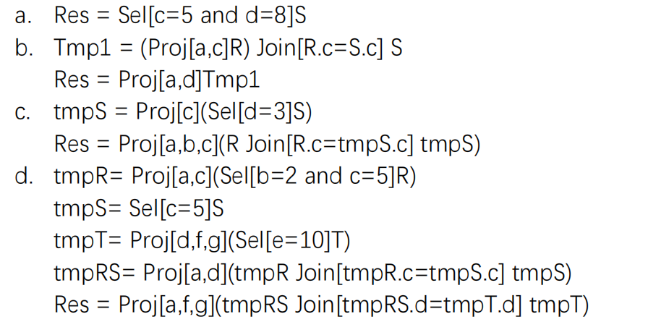

**Transaction**

前驱图用于表示事务之间的依赖关系，是判断事务可串行化的一种图形化工具。

在前驱图中，每个事务对应一个节点，每个数据项对应一个节点。

如果一个事务 T1 读取了另一个事务 T2 写入的数据项 A，那么就会从 T2 对应的节点到 A 对应的节点连一条有向边，T1—>T2

如果一个事务 T1 写入了另一个事务 T2 读取的数据项 A，那么就会从 A 对应的节点到 T1 对应的节点连一条有向边，T1—>T2

如果一个事务 T1 写入了另一个事务 T2 写入的数据项 A，那么就会从 T2 对应的节点到 T1 对应的节点连一条有向边，T1—>T2

构造可串行化的视图是判断一组事务是否为View-serializable的一种方法(并且结果不会发生变化）

ACR schedule：由于没有对未提交事务修改的数据执行读取，因此也没有级联回滚的机会

**redo/undo**

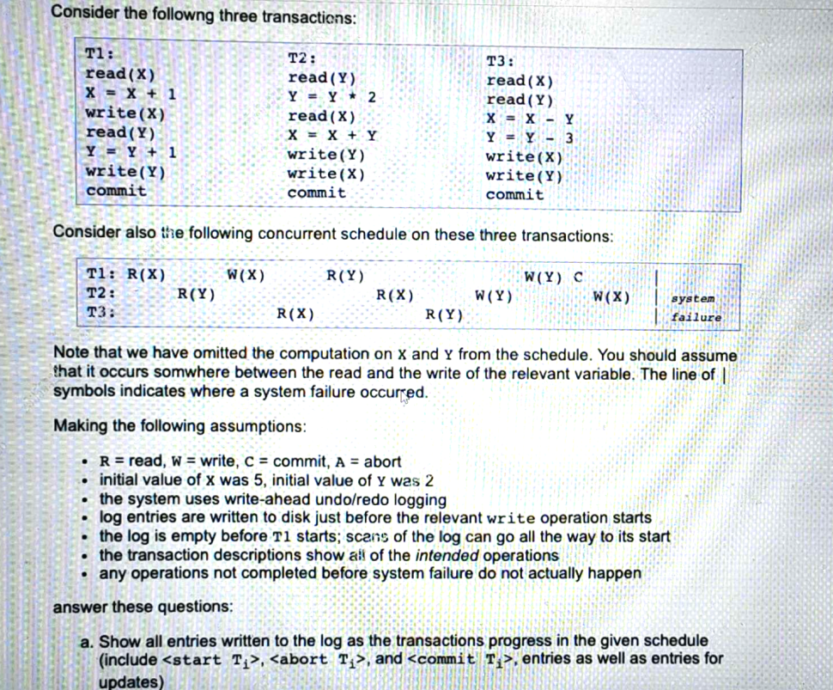

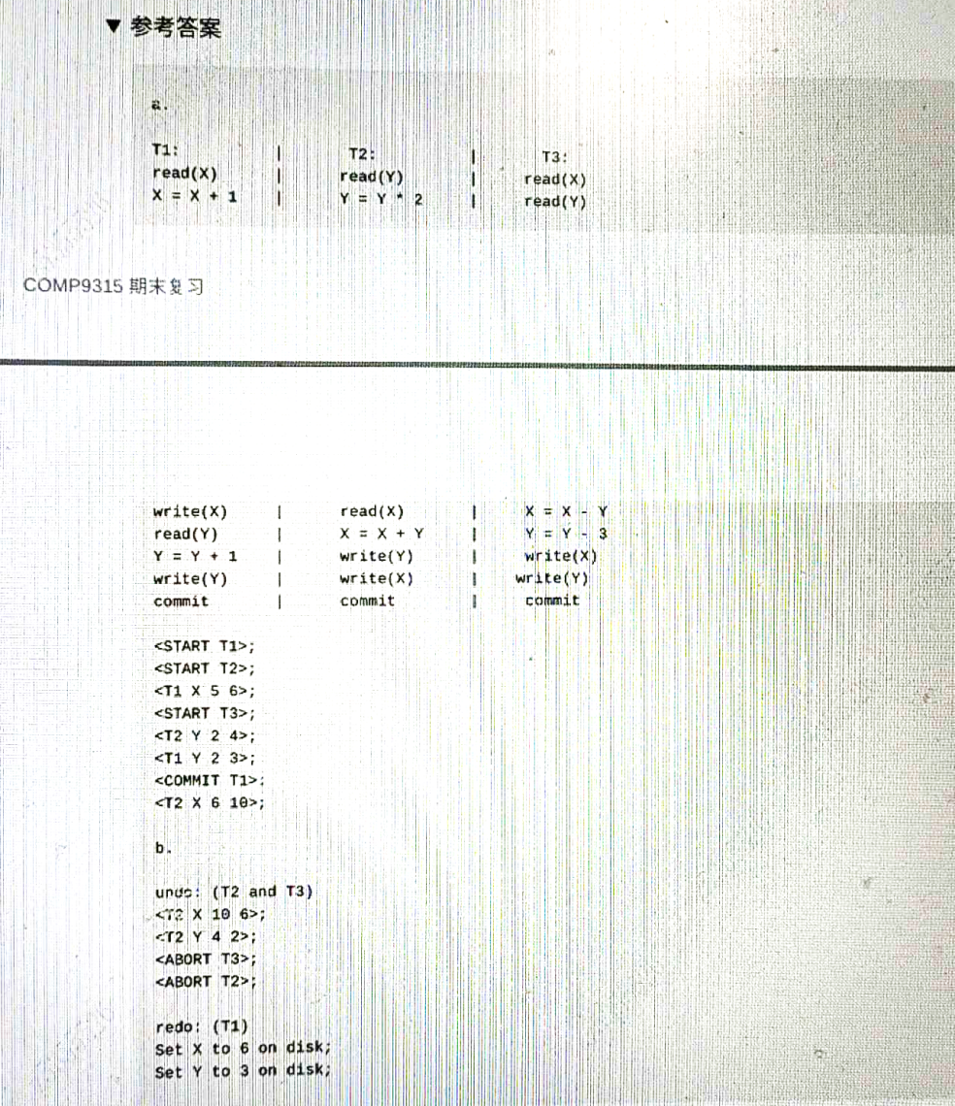

**代码**

**int open(const char *pathname（文件名路径）, int flags, mode_t mode);**（如read和write）进行文件操作。因此，open函数不会改变文件指针的位置。

**FILE *fopen(const char *filename, const char *mode)**;

直接用于文件操作（如fread和fwrite），因此它会改变文件指针的位置。

**fclose(fh)：**关闭由指针fh所指向的文件，返回值为0表示成功，EOF表示失败。这个很重要，每次用完文件要记得关闭，再用再打开！

**char *fgets**(char *str, int n, FILE *stream);

fgets函数是以行为单位读取文件数据，它会读取一行文本，包括行末的换行符，并将其存储在一个字符数组中。

**fgetc(fh)：**从文件中读取一个字符，返回值为该字符的ASCII码。如果读到文件末尾或出现错误，返回值为EOF。

**getchar()**：从标准输入流中读取一个字符，返回值为该字符的ASCII码

**fputc(c,fh)**：将一个字符c写入文件，返回值为写入的字符。如果出现错误，返回值为EOF。

**putchar(c)**：将一个字符c写入标准输出流，返回值为写入的字符。

**fputs(s,fh)：**将字符串s写入文件，返回值为非负数表示成功，EOF表示失败。fputs(s, fh) == EOF

**size_t write**(int fd, const void *buf, size_t count);

write函数是将指定数量的字节直接写入文件

**size_t fwrite**(const void *ptr, size_t size, size_t count, FILE *stream);

fwrite函数是按照块（block）写入数据，会先将数据写入缓冲区，然后在缓冲区满或者刷新时才将缓冲区的数据写入文件。其返回值代表成功写入的数据块的个数

**size_t fread(**void *ptr, size_t size, size_t count, FILE *stream);

fread函数则是以字节为单位读取文件数据，它会从文件中读取一定数量的字节，然后将这些字节存储到一个缓冲区中返回值代表成功读取到的数据块的个数

**int fputs**(const char *str, FILE *stream);

fputs函数是将一个字符串写入文件，和fwrite函数一样会先将数据写入缓冲区，但是不会将缓冲区的数据刷新到文件中，直到缓冲区满或者调用fflush函数。因为fputs函数只能写入字符串，所以比较适合写入文本文件。

**fwrite(p,size,nel,fh)**：将nel个大小为size的元素从p指向的内存区域中写入文件，返回值为实际写入的元素个数。

**fprintf(fh, format, list)：**将按照格式字符串format指定的格式输出到文件中，返回值为写入的字符数。

**sprintf(b, format, list)：**将按照格式字符串format指定的格式输出到字符串b中，返回值为写入的字符数。

**scanf(format, list)：**从标准输入流中读取输入，根据格式字符串format指定的格式将读取的数据存储到参数列表list中，返回值为成功读取的参数数目。

**sscanf(s, format, list)**：从字符串s中读取输入，根据格式字符串format指定的格式将读取的数据存储到参数列表list中，返回值为成功读取的参数数目。

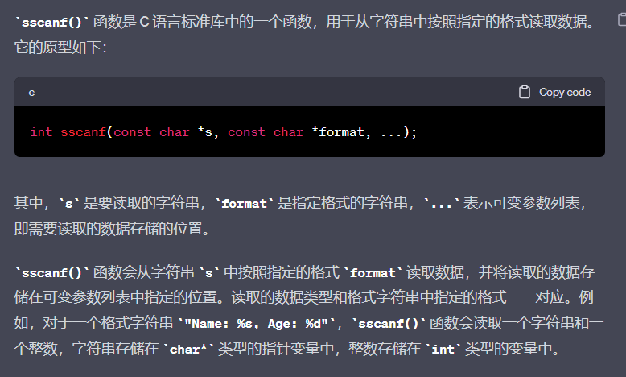

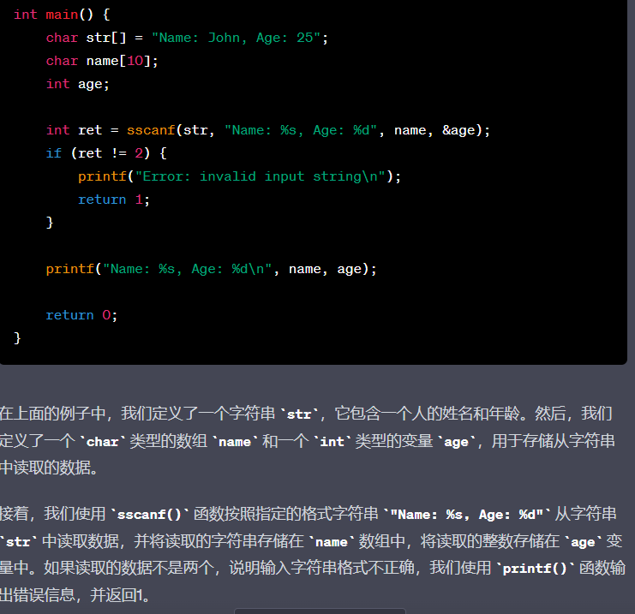

**toupper(c) 和 tolower(c)** 分别将字母字符转换为大写和小写形式，参数 c 是要转换的字符，返回值是转换后的字符。

**isupper(c) 和 islower(c)** 分别用于测试一个字符是否为大写或小写字母，参数 c 是要测试的字符，返回值是非零值（表示真）或零（表示假）。

**isalpha(c)、isalnum(c)、isdigit(c) 和 isxdigit(c)** 分别用于测试一个字符是否为字母、字母或数字、数字和十六进制数字，参数 c 是要测试的字符，返回值是非零值（表示真）或零（表示假）。

**isspace(c)** 用于测试一个字符是否为空格字符（包括空格、制表符、换行符、回车符、垂直制表符和换页符），参数 c 是要测试的字符，返回值是非零值（表示真）或零（表示假）。

**strlen(s)** 用于计算字符串的长度（不包括字符串结束符 '\0'），参数 s 是要计算长度的字符串，返回值是字符串的长度。

**strcpy(sd,ss) 和 strncpy(sd,ss,n)** 分别用于将一个字符串复制到另一个字符串中，参数 sd 是目标字符串，ss 是源字符串，n 是复制的字符数（strncpy() 中），返回值是指向目标字符串的指针。

还有一种为**memcpy(new,a,strlen(a)) strcpy只读到’\0’结尾，memcpy会指定读取的字符串长度**

**Memcpy(new,a,strlen(a));**

**Memcpy(new+strlen(a),word,strlen(word)+1);**

**第一步将字符串a复制给new，再将word的字符串复制给new指针移动a个后的位置,+1是为了将word字符串后面的\0也复制，最终new变成了一个结合了a和word两个字符串的字符串。**

**strcat(sd,ss) 和 strncat(sd,ss,n)** 分别用于将一个字符串ss连接到另一个字符串sd的末尾，参数 sd 是目标字符串，ss 是源字符串，n 是连接的字符数（strncat() 中），返回值是指向目标字符串的指针。

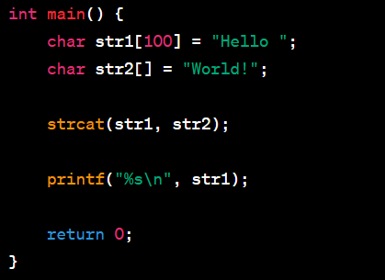

**strcmp(s1,s2) 和 strncmp(s1,s2,n)** 分别用于比较两个字符串是否相等，参数 s1 和 s2 是要比较的字符串，n 是比较的字符数（strncmp() 中），返回值是一个整数，表示两个字符串的比较结果。如果 s1 大于 s2，则返回一个正整数；如果 s1 小于 s2，则返回一个负整数；如果 s1 和 s2 相等，则返回 0。

**strchr(s,c) 和 strrchr(s,c)** 分别用于在字符串中查找某个字符的第一个出现位置和最后一个出现位置，参数 s 是要查找的字符串，c 是要查找的字符，返回值是一个指向找到的字符的指针，或者是空指针NULL（如果未找到）。

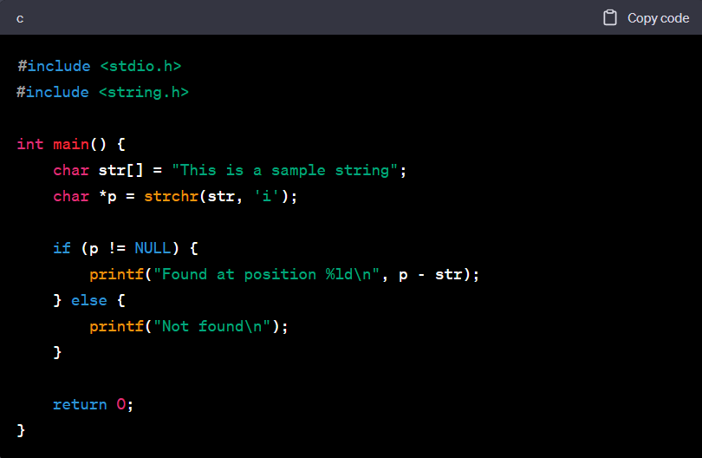

1. str代表两个指针之间的偏移量（单位为字节）

**strstr(s,sp)** 用于在字符串中查找另一个字符串的第一个出现位置，参数 s 是要查找的字符串，sp 是要查找的子字符串，返回值是一个指向找到的子字符串的指针，或者是空指针（如果未找到）。与strchr函数原理相同。

**strpbrk(s,set)** 用于在字符串中查找某个字符集中的任何字符的第一个出现位置，参数 s 是要查找的字符串，set 是要查找的字符集，返回值是一个指向找到的字符的指针，或者是空指针（如果未找到）。

**strspn(s,set) 和 strcspn(s,set)** 分别用于计算一个字符串中匹配字符集中字符的个数和不匹配字符集中字符的个数，参数 s 是要计算的字符串，set 是要匹配或不匹配的字符集，返回值是计算结果（字符数）。

**char *strtok(char *str, const char *delim)**;strtok() 函数用于将字符串分解为一组标记. str 是指向要分解的字符串的指针，第二个参数 delim 是指向分隔符字符的指针。该函数返回一个指向下一个子字符串的指针，如果没有更多的子字符串，则返回 NULL。

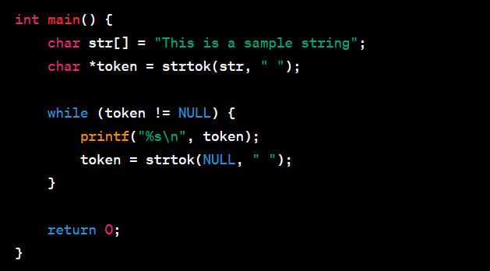

**char *strdup(const char *str);**它可以用来复制一个字符串，并返回一个指向新字符串的指针。



